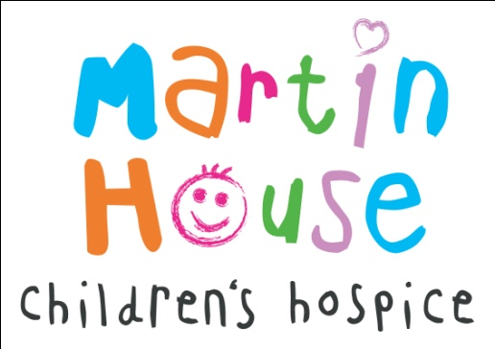
MARTIN HOUSE SERVICE EVALUATION
Consent Form

Please read and answer every question.
TO COMPLETE
YES NO
Do you understand what the project is about
and what taking part involves?
Do you understand that you do not have to take part
and that if you do, you can leave the project at any time
without giving a reason?
Do you understand that the information you share will
be used to write a report about Martin House services?
Do you understand that your name will not be identified
and that the information you share will not be given
to anyone else?

Would you like to take part in the project?
If yes, is it OK to record your interview?
Name of participant:
Signature of participant:
Name of researcher:
Signature of researcher:
Date of interview:

You will be provided with a copy of this consent form by post.

